Edmond Town Hall Board of Managers Phone: (203) 270-4285
45 Main Street Fax: (203) 270-4287
Newtown, CT 06470 Email: rentals@edmondtownhall.org

Date of Use:_________________________________ Start Time: ___________________ End Time: ____________________ Organization:_______________________________________Email:____________________________________________________Person in Charge:_____________________________________________________Phone:________________________________ Email Address:_________________________________________________________________________________________________ Address:_________________________________________________________________________________________________________

Please choose the room that best suits your needs:

____ Mary Hawley Room ____ Lower Meeting Room (may require event insurance)

For Office Use:
Room Rental Fee:  Posted on Calendar: Y | Date Due:  Received: | Form of Payment:  Check Credit Card
Security Deposit Amount: | Date Due:  Received: | Form of Payment:  Check Credit Card
Refund of Security Deposit: | Date Due:  Received:  Refunded: | Form of Payment:  Check Credit Card

Your rental fee is due upon booking your reservation. Please see the rate sheet for rental rates and room capacity. Checks should be made payable to: ETH, Board of Managers.

A refundable security deposit of $50 is due 30 days prior to your reservation date. At that time you must also provide a certificate of insurance.
This facility closes at 10pm Mon-Thurs and 11pm Fri-Sun. The security deposit will be returned, provided the facility is left as it was found and the time constraints are adhered to. The deposit will be returned or forfeited at the discretion of the Edmond Town Hall administration.

If cancellation occurs, more than 30 days prior to the scheduled event, a full refund will be provided. If cancellation occurs within 30 days of the event and the premises can be relet, a full refund will be provided. Otherwise a credit will be offered to use towards a future rental date.
Lessee acknowledges that the premises are historic in nature and the heating and air conditioning systems are subject to malfunctions. Lessee agrees that if there is a failure of the air conditioning and/or heating systems that no refunds or credits will be provided.

Lessee Signature:_____________________________________________________________Date:_____________________
Printed Name: ___________________________________________________________________________________________
ETH Representative Signature: ______________________________________________________Date:_____________

The Town of Newtown is pleased to be able to offer the Edmond Town Hall for rental to our residents and other local companies and entities.
The Board of Managers of the Edmond Town Hall of the Town of Newtown works very hard to maintain this facility to ensure that it is a clean and safe place available for the enjoyment of all our residents. It is an unfortunate reality that injuries do sometimes occur while the premises are rented to others.
The Edmond Town Hall Board of Managers and the Town of Newtown do not provide supervision over the activities or events that take place during a short-term rental of their facility. To that end, it is not the intention of the Town of Newtown to assume liability for bodily injury that might occur during a short-term rental. Instead, it is the intent of the Town of Newtown to transfer liability by contract to the individual or entity that is renting the facility. Additionally, the Town of Newtown has specific insurance requirements that must be adhered to.

Accordingly, please read the following Indemnity/Hold Harmless Clause:
DEFINITIONS:
1. Lessee: The person or entity requesting to rent the facility.
2. Landlord: The Town of Newtown, Borough of Newtown and all elected or appointed boards
and commissions and authorities, officials, directors, officers, employees and
volunteers, all when acting or deemed to be acting within the scope and
performance of their duties.
3. Premises: The facility that is the subject of the rental.
4. Term: The time during which the facility is rented to the lessee.
Lessee will indemnify and hold the Landlord harmless from all claims arising from or in connection with (i) the rental, leasing, occupancy or use of the Premises, or any condition created in or about the Premises during the Term; (ii) any act, omission or negligence of Lessee or the partners, directors, officers, agents employees or invitees of the Lessee; (iii) any accident, injury or damage whatsoever occurring in or at the Premises including claims arising out of any type of virus, bacteria, or any other microorganism that induces or is capable of inducing physical distress, illness or disease. Lessee hereby expressly indemnifies Landlord for the consequences of any negligent act or omission of Landlord, its agents, servants and employees. Unless such act or omission constitutes gross negligence or intentional misconduct.
My signature below will serve as proof that I have read all of the above information and fully understand the intent of the Indemnity/Hold Harmless Agreement.
____________________________________________________________________________________________________________ Printed Name of Individual or Entity Requesting Rental
Signature: __________________________________________________________ Date:_______________________________

To promote the health and safety of your guests, our staff, and other users of this space, we require that you follow the guidelines below when renting space at ETH.
1. All events or activities in the building must have an assigned overseer to ensure that all health guidelines are followed. The person renting the space will be considered the overseer and will be responsible for making sure that their guests follow all regulations. The signer of this document will also be the overseer.
2. Edmond Town Hall also reserves the right to require for events, renters and guests
any regulations mandated by local, state and/or federal officials.
3. Edmond Town Hall reserves the right to cancel your event if the directive from local and state health officials requires it or if the event is deemed unsafe and/or participants are not following mandated guidelines.
4. Do not use tape/signs on floor, walls, woodwork.
5. NO SMOKING in the building.
6. Garbage bags should be closed and placed in appropriate bins provided by ETH.
7. Music must be kept at a reasonable level.
8. Guests are expected to behave while in the building and on the grounds.
9. Please remove all food and decorations you brought for your event at the end
of your rental period and take with you or discard in provided trash cans.

Your Name: _____________________________________________________________________________ Date:______________________
Signature:____________________________________________________________________________________________________________

Edmond Town Hall accepts personal checks, debit and credit cards or cash. Cash payments must be made in person during office hours. All other payments may be made by mail or email using this form. We do not accept payment without contracts.

The rental fee for your event is due 7 days after your reservation is approved. We do not accept payment without paperwork.

To pay by check, please mail a check with your paperwork or drop off to:

Edmond Town Hall-Board of Managers
45 Main Street
Newtown, CT 06470

Make checks out to: ETH-Board of Managers or ETH-BOM

If dropping off after hours, there is a black mailbox on the door of the business office. Please do not
leave cash.

Electronic invoicing is available. Please email finance@edmondtownhall.org to request an invoice.

To pay by credit or debit card, please complete the following information and mail, fax or email it in with your paperwork: (Please note: rental service payments made by debit or credit card will incur a 3.5% service fee. Checks or money orders incur no fee.)

________________________________________________________________________________________
Name on Rental Reservation/Date(s) and Location of Rental

_______________________________________________________________________________________
Credit Card Number

________________________________________________________________________________________
Credit Card Expiration Date

________________________________________________________________________________________
Credit Card Security Code (3 or 4 digit number in back of card; on Amex it’s in front)

__________________________________________________________________________________________
Billing Zip Code for this Credit Card

Insurance requirements for individuals, companies, businesses, church groups, social clubs, civic organizations:
Fortunately, most businesses, churches, etc. already have in place an insurance policy that can be easily modified to provide coverage for your event. The policy is called a Commercial General Liability (CGL) policy.
- If your entity currently has in place a CGL policy:
Contact your insurance agent and have them issue a Certificate of Insurance (COI).. Please tell your agent that if the information contained on the COI they issue on your behalf differs from the example attached, please explain in writing.
- If you or your entity do not currently have in place a CGL policy:
You will be required to purchase a one-day Participant Accident Insurance Policy. This can be purchased through the Town of Newtown through CIRMA which underwrites a Tenant User Liability Insurance Program (TULIP) which allows renters to purchase insurance per event or on a per day basis. The directions for accessing the application for insurance are below:
Below are the insurance options that you can use for your Edmond Town Hall event rental. Also attached is a sample insurance certificate. This demonstrates our insurance requirements so that you know what coverage you need regardless of what company you choose to use.
→ The first insurance option is GatherGuard, an event insurance company available through this link: www.gatherguard.com
When you use the GatherGuard website, you will be asked to enter the following Venue ID: 0501-1046. This will bring up the venue: “Edmond Town Hall.” Click on the “Next” button at the bottom of the page and you will be asked to answer a series of questions. In the end, you will be given a price quote and an opportunity to purchase the insurance. Be sure to mail or email us the insurance certificate you receive after your purchase. This certificate is due 30 days before your event.
→ The second insurance option is: http://www.privateeventinsurance.com/
Please be sure to use the same coverage as is listed on the sample certificate. If there will be alcohol at your event, be sure to get additional liquor liability insurance.

If you have commercial liability insurance through your business or organization, or you use an insurance company other than TULIP, please request a certificate of insurance from your agent naming Edmond Town Hall as the “additional insured” with the coverage as outlined in the directions and sample certificate. Send the certificate to us 30 days before the date of your event.

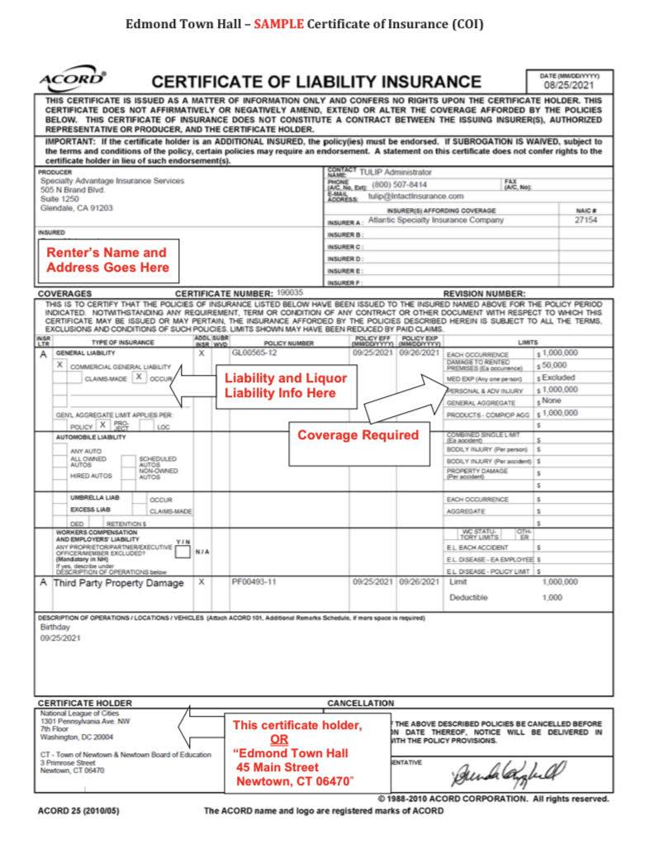

Name: ____________________________________ Date of Use: _____________________

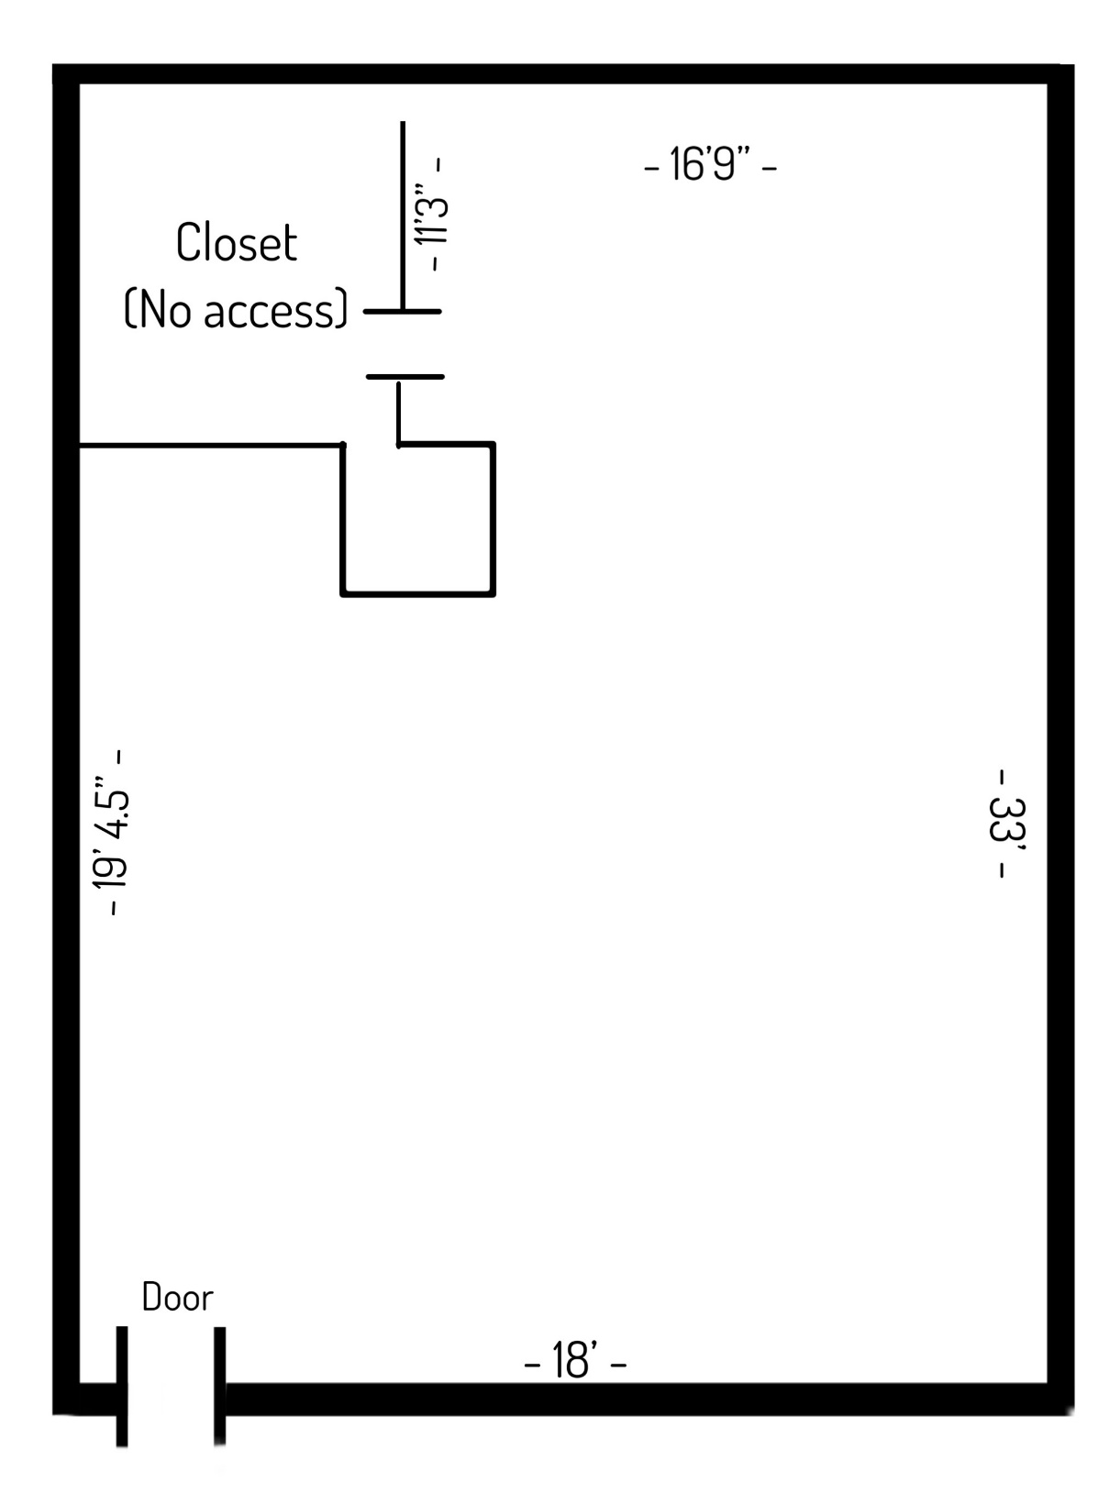

*Max occupancy – 46 people*
6’ rectangular tables and chairs provided

ALEXANDRIA ROOM
*$200 Refundable Security Deposit due for each event*
*Includes tables, chairs and set up of room, including pantry and kitchen if applicable*

Event Rental (Room Only) | $375
Event Rental with Kitchen (no china) | $475
Event Rental with Kitchen & China (includes 5-pc China place setting, wine and water glasses) | $500
Kitchen Only (Sunday through Thursday only) | $30/hr
Cool Kitchen Rental (access to refrigerator and sink only) | $25
Meeting Rental (no kitchen) | $45/hr
Meeting Rental with Kitchen | $65/hr
Wedding Rental (two days - one set up, one event & break-down)  *option to add $150 for balcony buyout/private second floor use* | $1200
Memorial (Room Only, 4 hours) | $190
Memorial with Kitchen (4 hours) | $290

GYMNASIUM
*$50 Refundable Security Deposit due for each event*

Sports, general use and parties (3 hour minimum) | $35/hr
Evening events (events between 5pm-building close) | $300
All day rental (7am load-in) | $600

THEATER

Full Day Rental (Mon-Thurs 8am-10pm) *$500 Deposit required. | $1850
Full Day Rental (Fri-Sun 8am-11pm) *$500 Deposit required. | $2950
Theater Party - AM (8:30-12:30, movie included) | $250
Theater Party - PM (3:30-6:30, movie included) | $325
Corporate Meetings (Mon-Fri, 4 hour limit with 6pm completion) | $950

*Full Day Theater Rental includes custodial services and use of dressing rooms, main lobby and box office. Also includes our in-house technical director for up to 10 hrs of support. A fee of $50/hr will be charged for anything over 10 hrs.
*Edmond Town Hall does not provide sound and lighting services. Renter must pay for those services separately.

GENERAL MEETING ROOMS

Social Groups, Lessons & Meetings | $30/hr

Please note:

Building closes at 10pm M-Th and 11pm Fri-Sun. For any event that goes beyond closing time, additional fee will be billed @ 45.00 per hour.

Documentation of Non-Profit status for income tax purposes required with signed contract. We offer a 10% discount to Non-Profit Organizations.
Rental fees are due 7 days after booking the event. The security deposit is due 30 days prior to the event and will be returned to the renter following a satisfactory inspection within 15 days after the event. Cleaning and repair costs for any damage will be deducted from the security deposit.

Our goal at Edmond Town Hall is that we provide a space to be enjoyed by all. The following questions will be used to understand who we are currently serving effectively and those we could do a better job serving. Your responses will be kept confidential and none of the questions are required.

1. Please indicate the number of people in each age group that will be participating in your event.

● Children 17 or younger: _______
● Adults 18 to 64: _______
● Adults 65 or older: _______

2. Which if the following best describes you? (Choose all that apply.)

____ African American or Black
____ Asian or Asian American
____ Hispanic or Latino/Latina
____ Middle Eastern or North African
____ Native American/American Indian or Alaska Native
____ Native Hawaiian or Pacific Islander
____ White
____ Other: ________________

3. What state do you live in?

____ Connecticut
____ Other: ________________

